Puzzle of the (st)Ring
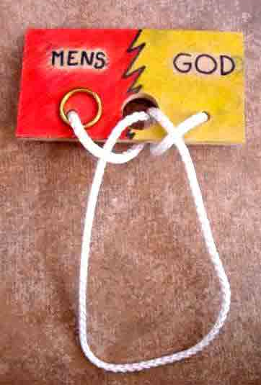
This puzzle probably originates in China: How to get a big ring through a small hole from one side of the puzzle to the other. In the puzzle the left side represents "MEN" and the right side GOD.
The ring as a symbol of ourselves with our sinfull life can only follow the rope to the other side – God – through a special deal at the backside of this puzzle, God’s secret. This has a deeper meaning what makes this puzzle interesting for missionwork.
How can man come to God - how can man be reconciled and have peace with God?
This puzzle illustrates our inability to be reconciled with God on our own. Other religions in this world are based on the idea that men can save themselves but Jesus teaches us on the contrary that it is impossible. There is only One Way: Jesus! He reconciled us with God by His volunteer death on the cross and His resurrection!
This puzzle illustrates Gods solution for our problems: Step in the open arms of God and accept His Help, His Solution through Jesus Christ!
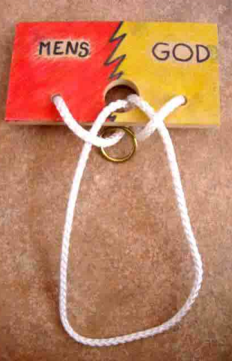
The ring is an illustration of our lives infected with sin. This makes it impossible to pass the hole and find the way back to God.
Put the puzzle as shown above, pull to make the long string in the midst large to symbolize the open arms of God.
When people put their lives in the open arms of God and belief His Word, that your sins are forgiven by faith in Jesus Christ, God is going to solve your problem. That is the secret.
Put the ring in the big bow in the middle... that symbolizes your capitulation, surrender to and faith in God. God is going to save your problem.
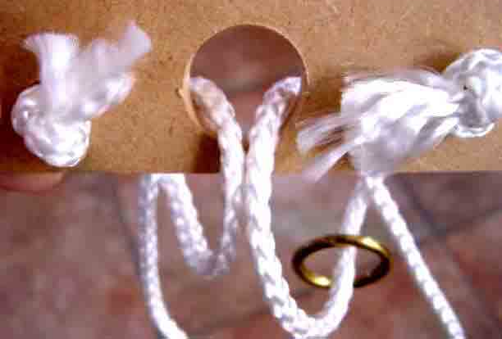.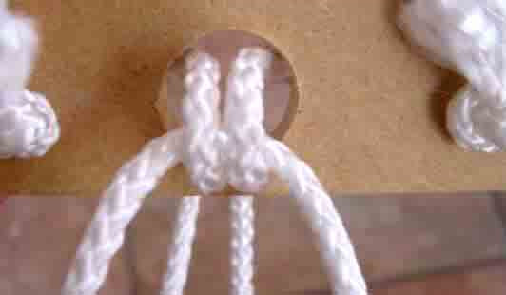
Turn the puzzle to see the backside, God’s secret Solution for our problem of sin: Jesus is the Way, the Truth and the Live. John 14:6.
Pull the string that emerge on the hole on the backside. Pull till also the sidestring come through the hole. This is shown in the pictues above and below.
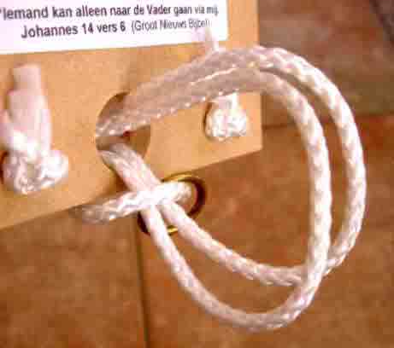.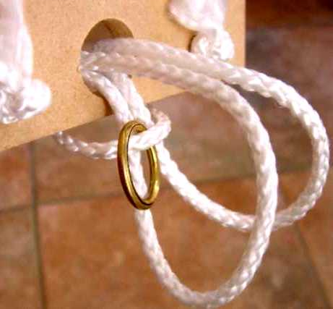
Go on pulling till you have enough to make an opening as shown in the picture above. This opening is "The Way" to push the ring through. Let the ring go through this Way. Spritual this represents forgiving of our sins and be borne again. Actually we are now reconciled and have become children of God. The ring - our live - is at the side of God.
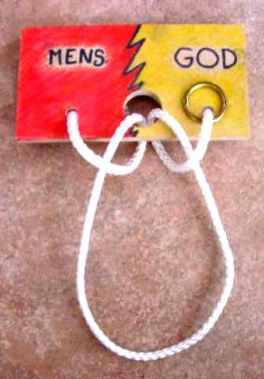
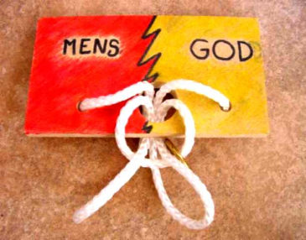
Turn the puzzle again and pull the strings all back through the hole to the frontside. Till the big bow, the "open arms", appear again. The ring can now be moved towards God without any barrier left. This symbolizes reconciliation and a new live as a child of God through Jesus.
The front of this puzzle can be painted in appropriate colors or a text written like: "be ye reconciled to God" (2 Cor 5:20). At the backside you can write John 14:6 ... Jesus saith " I am the way, the truth, and the life: no man cometh unto the Father, but by me."

May this puzzle and it’s explanation help understand the good news of Jesus Christ!

